# CSE4001 - Parallel and Distributed Computing

# Lab 21+22

# Digital Assignment- 4

# Submitted by: Alokam Nikhitha

# Reg No:19BCE2555

# QUESTION:

Write a C program to handle message passing in the MPI application interface, which allows processes to communicate with one another. Create two processes that will pass the number 17 from one to the other.

# CODE:

#include <stdio.h>

#include <mpi.h>

int main(int argc, char** argv) {

int process_Rank, size_Of_Cluster, message_Item;

MPI_Init(&argc, &argv);

MPI_Comm_size(MPI_COMM_WORLD, &size_Of_Cluster);

MPI_Comm_rank(MPI_COMM_WORLD, &process_Rank);

if(process_Rank == 0){

message_Item = 17;

MPI_Send(&message_Item, 1, MPI_INT, 1, 1, MPI_COMM_WORLD);

printf("Message Sent from Process 0: %d\n", message_Item);

}

else if(process_Rank == 1){

MPI_Recv(&message_Item, 1, MPI_INT, 0, 1, MPI_COMM_WORLD, MPI_STATUS_IGNORE);

printf("Message Received in Process 1: %d\n", message_Item);

}

MPI_Finalize();

return 0;

}

# CODE SNIPPETS:

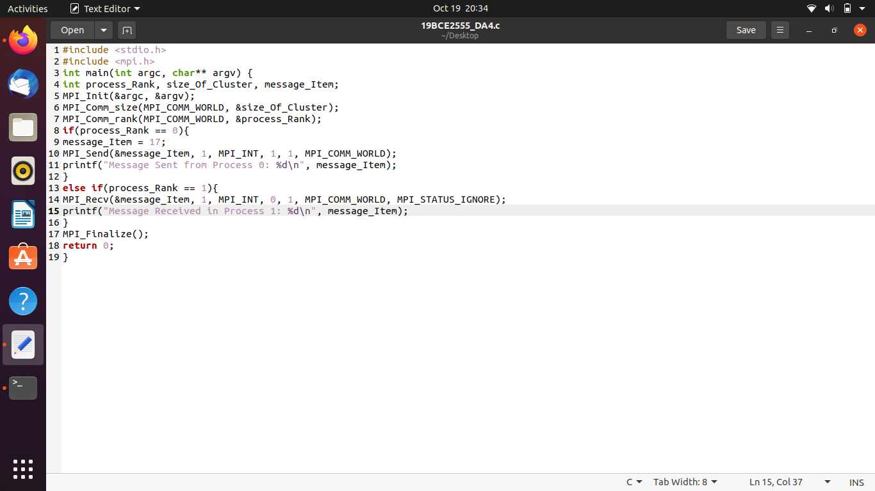

# OUTPUT:

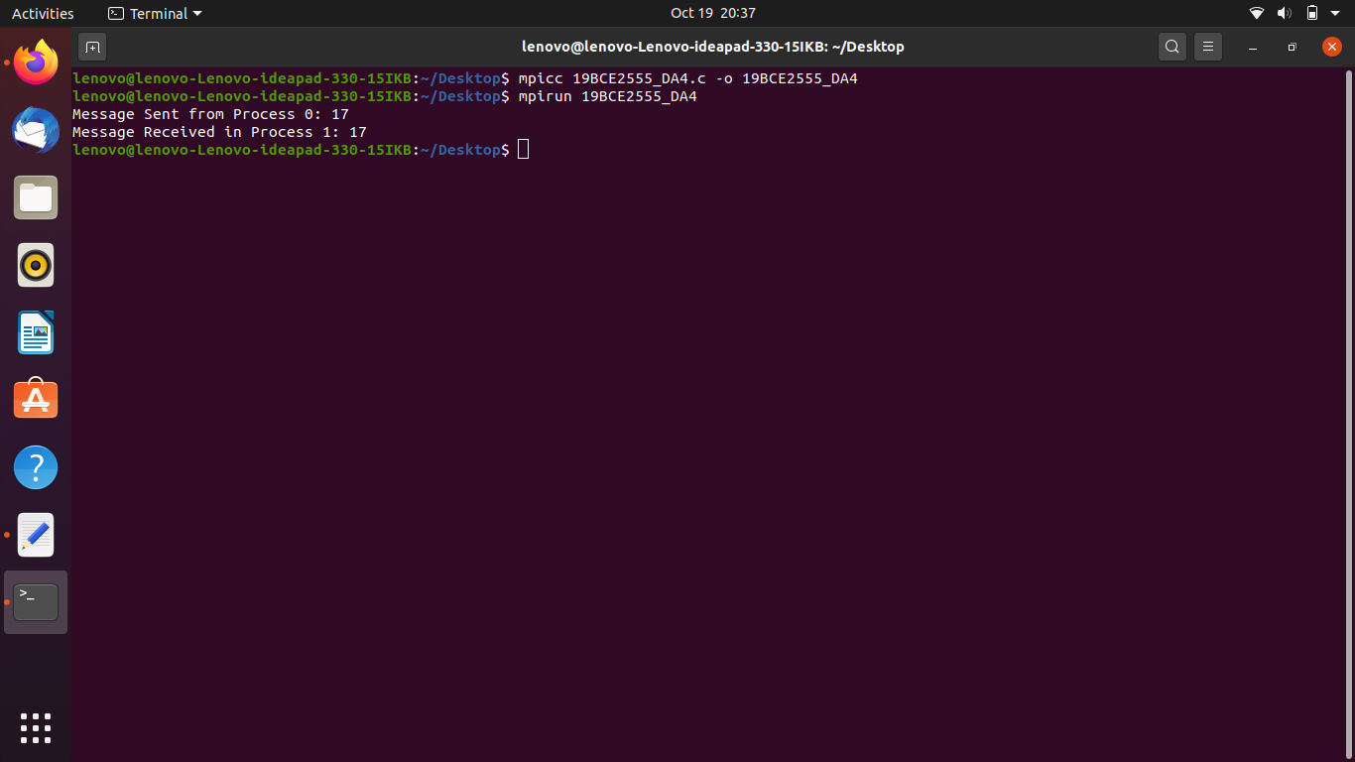

**OUTPUT WITH CODE:**

